I. QuickBooks Online Integration

1. Which records must the app exchange with QuickBooks Online?
Answer: _____Invoices, credit memos, and payments, customers_____________________

- Customers/clients
- Projects/jobs
- Vendors/subcontractors
- Estimates
- Change orders
- Bills and expenses
- Invoices
- Payments
- Time entries
- Cost codes, budget amounts, and actual costs

2. For each record type, should the app only read from QuickBooks, only send to QuickBooks, or do both?
Answer: ___________both_________________________________________________________

3. QuickBooks is the accounting source of truth. Which records, if any, should begin in this app before being approved and sent to QuickBooks?
Answer: ___________invoices_________________________________________________________

4. At what point should an approved change order be sent or marked ready for QuickBooks?
Answer: __________when invoiced__________________________________________________________

5. Should synchronization happen immediately, on a schedule, or only when an authorized user selects **Sync**?
Answer: ____________either way________________________________________________________

6. Does anything require approval before it is sent to QuickBooks? If so, what requires approval and who can approve it?
Answer: ___________________no_________________________________________________

7. Who should receive and resolve synchronization errors or conflicting data: the admin, accountant, or both?
Answer: _______________admin_____________________________________________________

8. How are projects and costs organized in QuickBooks today? Ask about projects/jobs, products and services, classes, locations, and cost codes.
Answer: ______________customer (I stopped using jobs as it messes up)______________________________________________________

9. Is there one QuickBooks company file, and can a QuickBooks sandbox or test company be provided for development?
Answer: ____________________________________________________________________

10. Does historical QuickBooks or Buildertrend data need to be imported, or will the app begin with active projects and new transactions only?
Answer: ________________we can start fresh____________________________________________________

II. Invoices, Payments, and Financial Visibility

1. Are invoices part of the first release, or should they remain in QuickBooks only for now?
Answer: ____________________________________________________________________

2. If invoices appear in the client portal, what should clients be able to do?
Answer: __________yes, not pay online though don’t have that__________________________________________________________

- View invoice details
- Download an invoice
- See balances and payment status
- Pay online
- Ask a question about an invoice

3. How are invoices generated today: fixed payment schedule, milestone billing, progress/percentage billing, time and materials, or another method?
Answer: _____________invoices are from approved selection or change order_______________________________________________________

4. If online payments are required, which payment processor is used today? Should payment continue through QuickBooks Payments?
Answer: __________________________NA__________________________________________

5. Exactly which project financial information should a client see when making decisions?
Answer: _________________all that is fine, we don’t really do budget stuff though___________________________________________________

- Contract amount
- Approved and pending change orders
- Selection allowances, overages, and credits
- Invoices, payments, and remaining balance
- Budget or cost information

6. Exactly which project-level financial information should staff see: budget, committed costs, actual costs, remaining budget, estimated final cost, or project profitability?
Answer: ____________________________________________________________________

7. Should accountants have access to every project automatically, or only projects assigned to them?
Answer: ________________NA____________________________________________________

III. Subcontractor Access

1. Do subcontractors need their own login in the first release?
Answer: __________________No__________________________________________________

2. If they do, what should they be able to view or do?
Answer: _________________________NA___________________________________________

- View assigned projects and selected schedule items
- Receive and complete tasks or punch-list items
- View or upload plans, documents, and photos
- Participate in project messages
- Submit bids, bills, invoices, or change requests
- Complete daily logs

3. What financial information, if any, may a subcontractor see?
Answer: __________________________None__________________________________________

4. Should subcontractors see only information assigned directly to them, or broader project information?
Answer: ____________________________NA________________________________________

5. Who may invite, remove, and manage subcontractors: admin only, or admin and staff?
Answer: _____________________________NA_______________________________________

6. Do vendors, designers, or other outside collaborators need a different type of limited access?
Answer: _________________________________No___________________________________

IV. Change Order Workflow

1. Walk through a real change order from request to payment. Who requests it, prepares pricing, reviews it, sends it, approves it, and bills it?
Answer: PMs or management create it and send it to the client. No approval process. The change order becomes a part of the financials within the application and are added when the house is complete. The financials for the house are provided to the closing attorney.

2. Can clients request a change, or can only company staff initiate one?
Answer: Clients typically ask for a change to design, finishes, etc which initiates the change order.

3. What pricing details are required: line items, quantities, labor, materials, subcontractor costs, markup, tax, allowances, and cost codes?
Answer: All costs associated with a construction project are needed. They price everything for the project to send an accurate full cost of the home to the client.

4. If more than one client is assigned to a project, is one approval sufficient, or must every designated client approve?
Answer: One approval is sufficient. They can approve right in the client portal.

5. What should happen after a client declines a change order: revise the existing version, create a new version, or close it?
Answer: It would be negotiated and the change order would be changed. Add the option to keep the and modify the change order and also create a new change order. They can choose.

6. Can an approved change order ever be cancelled or revised? If so, who may do that and what audit record is required?
Answer: If a change order is approved, then the client changes something associated with it, a new change order would be issued and that first change order would be nullified.

7. How should an approved change order affect the contract total, project budget, schedule, invoice plan, and QuickBooks records?
Answer: It doesn’t change the contract. The cost difference gets added to the total cost inside the app. The financials for the project are linked to the financials in Quickbooks through the API.

8. Is authenticated approval still sufficient for change orders, or does this workflow require a formal e-signature later?
Answer: Authenticated approval is sufficient. Later we can add Docusign or something.

V. Client Portal, Documents, and Photos

1. Should clients be able to upload files and photos back to the company? If yes, where should those uploads appear and who should be notified?
Answer: Yes they can upload them to the client portal. Add a place for client uploads.

2. Which document types require client approval or decline?
Answer: Change orders, material options, proposals, contracts, etc.

3. If a project has multiple clients, does one document decision count for the project, or is a decision required from each client?
Answer: One is sufficient. Add an option for admin, manager, pm to add 1 approval or signature, or one from each client. They can assign the approval to all, or assign one to each client.

4. Should a client be allowed to change an approval or selection after submitting it? If so, until what point?
Answer: They cannot change approved selections in the portal. They would have to contact the company through email, phone, text, or portal chat to initiate it. The pm, manager, admin can then reinitiate the selections if warranted.

5. Is a decline reason required for documents and change orders?
Answer: No but it would help. Add a line that says if you don’t leave a reason, we may contact you to discuss it.

6. What file types and maximum file sizes must be supported?
Answer: Standard for something like this. Is 25mb too small or big? 15mb? 20mb?

7. Do progress photos need a gallery, dates, categories, captions, or client visibility controls?
Answer: No they should just be able to see the date uploaded and the images.

8. Is email sufficient for notifications in the first release, or is text messaging also required?
Answer: email is sufficient

9. Which events should send notifications, and should users receive each event immediately or in a digest?
Answer: Add events in notification settings and the contractor can check which events matter. We can default it to all or a selection.

VI. Schedule, Tasks, and Field Operations

1. Does each project use one master schedule, or separate schedules for office staff, field staff, and subcontractors?
Answer: Add the schedule feature, but this client doesn’t use scheduling in the app.

2. Should clients see the full project schedule or only selected milestones?
Answer: No

3. Who may create and update schedule items, and who should be notified when dates change?
Answer: Admin, manager, pm

4. Are dependencies, recurring items, calendar views, and external calendar integration required?
Answer: Yes

5. Are tasks and punch lists needed in the first release? If yes, must they support assignees, due dates, statuses, attachments, comments, reminders, and verification before completion?
Answer: Yes add them

6. Are daily logs required? If yes, what must they capture: labor, subcontractors, work completed, delays, deliveries, safety notes, weather, and photos?
Answer: No

7. Who creates daily logs, and who may view them?
Answer: N/A

8. Which workflows must work well on a phone? Is offline use required at job sites with poor service?
Answer: Whatever Buildertrend does for this.

VII. Finish Selections

1. Walk through a real finish selection from allowance setup through the client's final choice.
Answer: Whatever Buildertrend does for this. They use this feature.

2. Can clients choose only from company-provided options, or may they request a custom option?
Answer: They can request custom options, but they won’t be in the selections. It would trigger a change order.

3. Can a selection require more than one choice or approval?
Answer: Yes, multiple choices may be selected for different areas of the house.

4. How should allowance overages and credits be handled?
Answer: An overage requires a change order. It needs to be flagged for the pm, manager, admin to create the change order. Credits are to be flagged as well. Some credits can be applied in other locations. Some credits will just be ignored and considered profit, and some credits may be given back at closing.

5. Should an overage automatically create or update a change order, invoice, budget item, or QuickBooks record?
Answer: Flag it, notify contractor, admin, pms, etc. Suggest a change order with CTA.

6. What should happen when a client misses a selection due date?
Answer: An auto email option would be nice. Admin, manager, pm can send customer an email.

7. Do selections need vendor information, product links, specifications, photos, attachments, or lead times?
Answer: Contractor uploads images of each option. I would add vendor info, outside links to product, specs, photos, attachments, and lead times.

8. Can a completed selection be changed? If so, who can reopen it and what downstream records must change?
Answer: Yes it can be changed but not by customer. The admin, manager, or pm would have to reopen it for clients to have access to it.

VIII. Company Size, Usage, and Administration

1. Approximately how many projects are active at one time?
Answer: Any number. Currently 7. Could be more or less.

2. Approximately how many users are expected in each role: admin, staff, accountant, client, and subcontractor?
Answer: It doesn’t matter. Anyone can be assigned to any role.

3. Who besides admins may invite clients to a project? Should assigned staff be allowed to send and resend invitations?
Answer: Anyone given the permissions when the project is created. See image down below.

4. Can staff access every company project, or only projects to which they are assigned?
Answer: Only projects they are given permissions to.

5. Does the company need more detailed staff roles, such as project manager, superintendent, office manager, or read-only staff?
Answer: Admin, manager, project manager (PM), staff, office manager, Real Estate Agent

6. Are there required password, multi-factor authentication, session timeout, or audit-retention policies?
Answer: Authentication is required by all staff and clients. Add 2fa as an option for all. Admins can decide who needs 2fa. We can also add an option to use an authenticator phone app.

IX. Scope and Launch Priorities

1. What are the three biggest problems with Buildertrend that this app must solve?
Answer: Too many features. Too expensive.

2. Which three workflows are most important for the first usable release?
Answer: Client portal with messages, approvals, material selections, etc. Project pricing. All products, materials, labor, commission, etc. need to be applied and totaled. Be like Buildertrend for pricing everything. Change orders, image uploads for both builder staff and clients, quickbooks integration.

3. Which current Buildertrend modules are used today, and how should each be classified?
Answer: client portal, messaging/comments, files/photos, Quickbooks integration, change orders, job costing/budgets, estimates/proposals, finish selections, add crm (no leads).

- Client portal
- Messaging/comments
- Files/photos
- Invoices
- Online payments
- QuickBooks integration
- Scheduling
- Tasks/punch lists
- Change orders
- Daily logs
- Job costing/budgets
- Estimates/proposals
- Time clock
- Finish selections
- Warranties
- CRM/leads
- Subcontractor portal

The contractor can choose who views what in a project. Like Buildertrend has. See image.
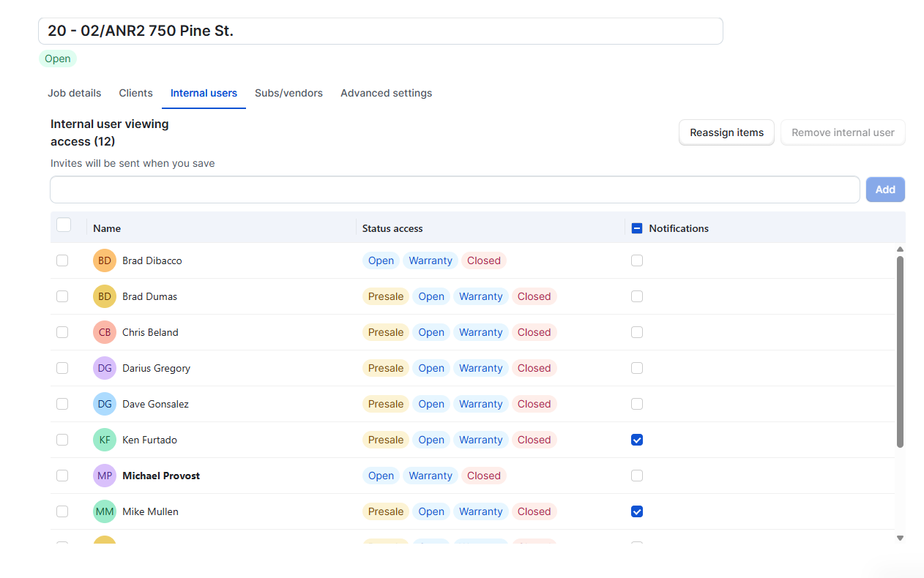
How the selection list should look:
